Cryogenic ASU Technical Scheme Specification:

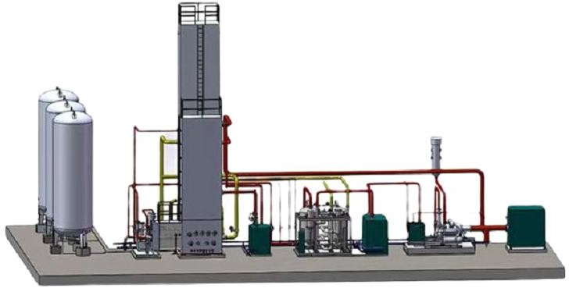

Date:2024-7-1

# Company Profile

Our locating by the Fuchun River of Hangzhou, is known as the professional manufacturer of air separation industry. The factory owns 14,000 m² total plant area. There are all together 106 employees, including over 50 workshop workers and 5 senior technicians. The office building, mainly for sales and marketing department, is in Fuyang, about 25-mins driving away from the factory. It is in a modern office building, and we one of the whole floor which occupies 2000 m².

devotes to provide the best solutions for customers with various demands of the air separation products, especially Oxygen and Nitrogen. Our product series overwhelmingly cover the whole air separation industry, such as large-scale cryogenic air separation series; pressure swing adsorption Series, purification equipment series; air compression&purification drying machine; low temperature storage tank etc. We also have advanced production lines for intelligent control valve.

The company have abundant overseas project experiences for all kinds of air separation products solutions in various industries. For examples, Cryogenic Air Separation Plant in Russia; Liquid Oxygen Storage tank&Gas station in Turkey; PSA Nitrogen Generator in Thailand; Oil Free Compressor in South Africa and Container Oxygen Generator in Chile. As long as you have needs for Oxygen, Nitrogen, liquid oxygen or liquid nitrogen, or other air separation plant related components such as compressed air purification system, compressed air filter, we are here to provide you with proper solution in professional ways.

# Project Overview

According to the friendly negotiation between the two parties, the scope of responsibilities is divided as follows:

* 1. The seller undertakes the scope of responsibility within the boundary of the air separation plant:

1. Process design, instrument electrical design, equipment design, and engineering design of the air separation plant.
2. The scope of supply of process equipment is as follows: 1 screw compressors, 1 air pre-cooling unit, 1 molecular sieve purification system (including molecular sieve and alumina), 1 fractionation tower system (including pearlescent sand), 2 sets Complete supply of expander system, 1 oxygen booster, 1 sets of filling platoons and instrument control system, electrical system, spare parts and special tools used in supporting the above process equipment; see "Appendix 5 Process Equipment and Instrument Electricity" for details Scope of supply".
3. The installation materials supplied by the seller within the boundary of the air separation plant include: process piping, cryogenic liquid piping from cold box to cryogenic storage tank, steel structure pipe gallery and supports, steel structure equipment and valve maintenance platform, Cable tray, power cable, instrument cable, instrument root valve, instrument sampling pipe (stainless steel), anti-corrosion and thermal insulation materials, cutting gas, solder and other auxiliary materials required for installation work.
4. The installation work in the boundary area of the air separation plant includes the following: the installation of the equipment mentioned in serial number (3), the installation of ancillary instruments and electrical appliances, the installation of process pipes, steel structure pipe gallery and brackets, steel structure equipment and valve maintenance platform Installation, installation of power cables and instrument cables, installation of cable trays, anti-corrosion and heat preservation work, filling work of molecular sieve purification system packing, filling work of pearl sand, the insulation material in the cold box, linkage test work, official start-up work, flaw detection, Also includes the installation tools required for the above installation work.
5. Junction point: the junction point of high and low voltage cables is bounded by the inlet end of the high and low voltage cabinet of the seller; the circulating water is connected by the buyer to 1 meter outside the boundary of the air separation unit; the junction point of the product liquid is at the liquid nitrogen storage tank; nitrogen gas It is the interface of the buffer tank before the out-of-bounds area;
6. Performance assessment, document delivery, technical service and after-sales service related to the air separation plant.
7. Assist the buyer to complete other work related to the air separation plant.
   1. The buyer undertakes the scope of responsibility within the boundaries of the air separation plant:
8. Responsible for the preliminary survey and detailed survey of the land within the boundary of the air separation plant, as well as the three connections and one leveling work within the boundary.
9. Responsible for the civil works in the boundary area of the air separation plant (mainly

greening work, central control room, power distribution room, pipe trench and cable trench), compressor workshop and Driving in the pump room, electrical professional lightning protection and anti-static, factory lighting, equipment lighting and telecommunications, structure, water supply and drainage, inspection and testing, security monitoring, HVAC, fire engineering design, materials, and construction.

1. Water, electricity, pressure test gas and mechanical materials for the commissioning and start-up of the air separation plant.

The production process of this air separation unit is a domestic advanced process, and the main equipment is imported or domestic advanced.

The device has many advantages such as high safety, reliable operation, strong operability and low energy consumption.

# Basic conditions of device design

(subject to the parameters provided by the buyer)

|  |  |
| --- | --- |
| 3.1 Atmospheric conditions design point |  |
| Atmospheric pressure | KPa（A） |
| Environment Temperature | 30℃ |
| Relative humidity | 70% |
| Oxygen content of Hb | 20.95% O2 |
| 3.2 Atmospheric temperature |  |
| Maximum temperature | 35℃ |
| Minimum temperature | -25℃ |
| 3.3 Seismic intensity | 6 degree |
| 3.4 Raw material air miscellaneous conditions |  |
| CO2 | ≤350ppm |
| C2H2 | ≤0.5ppm |
| H2 | <0.7ppm |
| CO | ≤0.5ppm |
| N2O | <0.3ppm |
| SOX | <0.2ppm |

|  |  |
| --- | --- |
| CnHm (regardless of C2H2) | ≤8ppm |
| Dustiness | 30mg/m³ |
| 3.5 Utility project condition： |  |
| 3.5.1 Cycling water |  |
| Inlet temperature | 33℃ |
| Temperature rise | 10℃ |
| Inlet pressure | 0.5 Mpa (G) |
| Pressure of return water | 0.25 Mpa (G) |
| Dirtiness resistance | 3.4*10-4 m³·K/M |
| 3.5.2 Power supply： |  |
| Standard power supply | 380V，220V |
| Frequency | 50+0.5/-0.5 Hz |
| 3.5.3 Instrument air (supplied by equipment after start-up) | |
| Pressure | 0.5MPa |
| Temperature | 32℃ |
| Dew point | -40℃ |
| Flow | 100Nm³/h |

# Main technical parameters of the device

* 1. Output and purity
     1. Main production A

|  |  |  |  |  |
| --- | --- | --- | --- | --- |
| Product | Output | Purity | Pressure MPa | Temperature ℃ |
| Oxygen | 50Nm³/h | ≥99.6% | 15 | Normal |

*Remark：

1. To make out product by varying the working condition.
2. The pressure of the liquid product is calculated based on the 0 elevation of the cold box. Nm³

/h refers to the state of 0°C and 760mmHg, and the pressure is gauge pressure unless otherwise specified.

1. The standard output to be 100m3/h, while it is adjustable to switch at range of 50m3 to 105m3 so as to save power consumption when you need less output.

|  |  |
| --- | --- |
| 4.2 Nitrogen dew point | ≤-60℃ |
| 4.3 Device variable load capacity range | 50-105% |
| 4.4 Device heating and thawing time | ～24 hours |
| 4.5Device start up time |  |
| Running expander to reach purity | ～12-16 hours |
| 4.6. Temporarily stop and restart to produce oxygen： | |
| Stop by 8 hours | 4 to 6 hours to produce oxygen |
| Stop by 24 hours | 8 to 10 hours to produce oxygen |

# Utilities consumption

* 1. The following process air (including instrument air) is required for the air separation unit of the raw material air to produce the above products

Raw material of air gas flow： 600Nm3/h

Air pressure： 1.0 MPa(G)

5.2 Main Consumption

|  |  |  |  |  |  |
| --- | --- | --- | --- | --- | --- |
| No. | Device Name | 380V | Water  Consumption | Qty | Remark |
| shaft/motor  power KW/set | t/h | Set |
| 1 | Air Compressor | 80/90 |  | 1 |  |
| 2 | Air Precooling Unit | 10/13 | 6 | 1 |  |
| 3 | Electric heater | 11/30 |  | 1 | 4h auto switch |
| 4 | Instrument control system | 3/3 |  | 1 |  |
| 5 | Cryogenic Liquid Pump | 8/8 |  | 1 |  |
| Total shaft power | | 112 | 6 |  |  |

**6. Brief description and characteristics of the process**

* 1. Brief description of the process

After the air is removed from the dust and other mechanical impurities by the suction filter, it enters the air compressor and is compressed to 1.0MPa (G), and at the same time, it is cooled to

≤ 40 ° C in the terminal cooler, and then cooled to 8 ° C by the refrigeration unit, and then enters the water separation unit. The water in it is separated by the device, and then enters the molecular sieve adsorber to remove H2O, C2H2 and CO2 in the air to obtain purification. There are two molecular sieve adsorbers, which work alternately, that is, when one is adsorbing, the other is regenerating. Factory air and instrument air are extracted after molecular sieve.

The purified air is divided into two paths: one path enters the fractionation tower, and enters the bottom of the rectification tower after being cooled in the main heat exchanger; the other path enters the fractionation tower, which is cooled in the main heat exchanger and then enters the expander for expansion and then enters the upper tower. The middle part participates in the upper column rectification to provide cooling capacity for the system.

The rising gas in the lower column is increased in nitrogen content by contact with the reflux liquid. The required reflux liquid nitrogen comes from a condensing evaporator at the top of the lower column, where oxygen is evaporated and nitrogen is condensed.

·Sewage nitrogen loop: A stream of dirty nitrogen is used for the regeneration of the molecular sieve adsorber, and a small part enters the cold box to inflate the cold box.

· Dry air for thawing: The air separation equipment instrument and the dry air for thawing (in normal working state) are extracted from the outlet of the molecular sieve adsorber and sent to the instrument air network.

·Instrument air: self-use instrument air self-sufficiency Liquid discharge: into the liquid storage tank

·Exhaust: The exhaust of the equipment is first sent to each muffler and then discharged into the atmosphere.

* 1. Process flow characteristics
     1. Air Compression System
* Adopt imported screw air compressor, high efficiency, low consumption, stable and reliable operation.
  + 1. Air pre-cooling system
* The air-conditioning unit adopts the combination of imported screw refrigeration compressor and all imported refrigeration components, load tracking of slide valve + hot gas bypass fine-tuning to stabilize the cooling air temperature, stainless steel tube and shell heat exchanger and collision + heavy sedimentation water separator combination automatically Separation of condensed water, air resistance loss ≤ 10kPa. Simple and convenient operation, noise ≤ 70dB (A).
* A water separator is set to remove free water, and a manual and imported automatic drain is set at the lower part to remove accumulated water regularly.
  + 1. Purification system
* The purifier adopts a vertical single-layer bed, which shows the advantages of 13X-APG

and the resistance loss is small. The built-in filter can be used for both blowing and purifier regeneration. High-efficiency electric heaters ensure thorough regeneration of molecular sieves.

* The switching cycle of the molecular sieve adsorber is 8 hours, the number of regenerations is small, and the power consumption is low.
* The switching valve adopts Nuzhuo products, with reliable action, zero leakage, grade VI seal, and long service life.
* The pressure equalizing valve adopts the regulating ball valve and cooperates with the pressure switch to realize the switching without impact.
* The electric heating tube adopts stainless steel straight rod type, which is easy to disassemble. When the electric heating tube fails, it can be extracted by a single piece, which is convenient for replacement. The electric heaters are configured according to one use and one backup.
* The power of the electric heater is controlled in three groups. When the outlet temperature of the heater is lower or higher than the set parameter, the power combination will automatically stop or start.
* The purifier regeneration heating gas volume and the electric heater are equipped with an interlocking device, the gas volume is lower than the set value and the circuit breaker is automatically protected, and when the gas volume is higher than the set value, it is automatically restored.
  + 1. Fractionator system
* This device does not have a separate heating system, and the fractionation tower is heated, cooled, liquid-accumulated and purified in one go, and the operation is simple and quick.
* Adopt aluminum plate-fin heat exchanger and aluminum convection sieve plate tower. The whole fractionation tower equipment pipeline adopts argon arc welding, which is safe and reliable, and realizes the continuous and stable operation of the device load at 75-105%.
* The turboexpander adopts gas bearing, which is simple and reliable, easy to operate and has high isentropic efficiency. The expander cold box is set separately for easy maintenance.
* The tower body and main pipeline in the cold box are made of high-strength aluminum alloy material or stainless steel material to increase the strength and reduce the torsional damage of the pipeline.
* The equipment brackets, pipes and valve brackets in the cold box should be made of stainless steel or aluminum alloy.
* The cold box is insulated with pearl sand and slag wool to ensure the minimum cooling loss.
* The instrument pipelines in the cold box should be arranged centrally, adopt protective measures, and be beautiful.
* The structure of the cold box needs to ensure the overall strength and the requirements of anti-vibration and wind resistance, to ensure the load-bearing capacity of the cold box, and to have a beautiful appearance.
* When the cold box is running, it is equipped with sealing gas protection and safety devices. Equipped with a sufficient number of manholes and pearl sand loading and unloading ports, allowing personnel at certain positions to easily enter the cold box for maintenance operations and the filling and disassembly of cold insulation materials.
* The main equipment in the cold box is set to electrostatic grounding.
* The connection between the cooling valve in the cold box and the pipeline is all welded,

Nuzhuo products. The low temperature manual valve adopts Hangzhou Nuzhuo products.

# Scope of supply of unit equipment (including but not limited to the following, which are complementary to the PID diagram)

1. The scope of supply provided by the seller is based on the principle of overall supply of each system and single unit. The scope of supply of each system and each unit, except for the main equipment and single unit, also includes necessary pipe fittings, paired flanges, anchor bolts, etc. in the boundary area.
2. Various valves for each system and each unit are supplied in complete sets.
3. Process pipelines, valves, instruments, fittings, etc. between systems.
4. The design of this equipment is based on the basic design conditions of the user's site, and the various equipment data provided are for reference only. To be determined at the final design stage, if the seller's final design changes, the commercial price will be adjusted accordingly.
   1. Air compressor unit (technical parameters are subject to the final design)
5. Manufactured by Wuxi Atlas factory, designed and produced according to international standards for Atlas series screw air compressors, with high compression efficiency, good reliability and low energy consumption; it will leave the factory after testing in the production factory;
6. The impeller of each stage runs at its optimum speed, and the ternary flow design has high stage efficiency;
7. The high-efficiency intercooler with pull-out type and fins is adopted, and the inter-stage cooling effect is good;
8. Constant pressure control, PLC + LCD touch screen data display, adjust the gas volume within the maximum possible range, with anti-surge operation, automatic pressure control, impeller vibration alarm chain and other protection measures. Standard excuse, can be connected with the host computer;
9. Perfect oil circuit system to ensure the normal and safe operation of the unit;
10. The whole machine is skid-mounted, which is easy to install and saves infrastructure costs

|  |  |
| --- | --- |
| Manufacture：  Atlas Copco (Wuxi) Compressor Co., Ltd. |  |
| Type：Screw  Model：G90 |
| Place of origin： Wuxi China |
| Parameter： |
| Medium | Air |
| Compression stage | Class 1 |
| Outlet air | 14.53Nm³/min |

|  |  |
| --- | --- |
| Inlet pressure/Temperature | 1.0Mpa(A)/35℃ |
| Outlet pressure/Temperature | 1.0Mpa(G)/≤45℃ |
| Connection diameter | DN50,PN16 |
| Shaft power | ～80kw |
| Motor power | ～90kw |
| Noise | ≤65 dB(A) |
| Regulating range | 100% |
| Power | 3PH/380V/50HZ |
| Total Weight | 1450kg |
| Size(mm) | 1610x990x1870mm |
| Quantity | 1 sets |

# Air pre-cooling unit

* 1. Device main description.

1. Using imported compressor, the refrigerant will never leak.
2. Using high-quality imported compressors and refrigeration components, the equipment can run continuously all year round and has a long service life.
3. Efficient gas-water separator and high-quality automatic drain valve ensure that the outlet air is free of liquid water.
4. Adopt advanced energy regulator to ensure that the compressor does not have to worry about frequent startup and shutdown.
5. The equipment displays the air inlet and outlet pressure, temperature, refrigerant high and low pressure, and the six main parameters are intuitive and clear.
6. The equipment has a remote signal interface for air inlet and outlet, a remote start and stop signal, and a fault signal for equipment operation, which is convenient for users to interlock and monitor.
7. The heat exchanger adopts (condenser, evaporator) with copper tube jacket as aluminum fin structure. The compressed air flows in the shell side, and the freon flows in the copper tube. This heat exchanger has a large heat exchange area, and heat exchange Good effect, good material, no corrosion, not easy to produce R410A leakage.

Pre-cooling unit equipment parameters

* 1. Design conditions (provided by the buyer)
     1. Design conditions of pre-cooling unit

|  |  |
| --- | --- |
| Cooling medium | air |
| Air input temperature | 42℃ |
| Air output temperature | 2-10℃ |
| Air flow | 600Nm3/h (0℃,0.1013Mpa per hour) |
| Air input pressure | 1.0Mpa（G） |
| Thermal load | ～224KW |

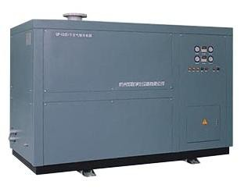

* 1. Equipment use conditions (public works)
     1. Cooling water temperature: ≤32℃;
     2. Cooling water pressure: 0.2-0.4Mpa (G);
     3. Power supply: 380V/220V AC three-phase four-wire system, 50Hz;
  2. Pre-cooling unit equipment parameters

|  |  |
| --- | --- |
| Model | GAYL-600/10 |
| Cooling medium | Saturated moist air |
| Air inlet temperature | ≤42℃（Saturated moisture） |
| Air outlet temperature | 5-8℃ |
| Air flow | 600Nm3/h (0℃,0.1013Mpa volume flow rate) |
| Air inlet pressure | 1.0Mpa（G） |
| Connecting diameter | DN100（HG20592B） |
| Thermal load | 33KW |
| Compressor type | 1 set of Scroll Refrigeration Compressor |
| Compressor Work Rate | 15HP |
| Input power | 10KW |
| Rated power | 13KW |
| Cooling capacity | 38KW |
| Cooling cycling water | 6T/h |
| Cooling water pipe diameter | DN40(screw joint) |
| Cooling type | Cycling water cooling |
| Water inlet temperature | ≤32℃ |
| Cooling water pressure | 0.2-0.45Mpa |
| Flange nominal pressure | 1.6Mpa |
| Working system | Work away |
| Process criterion | GB/T 10526 |
| Whole machine regulating range | 50%-100% |
| Cooling agent | R410A |
| Noise | ≤75dB |
| Power supply/Frequency | 380V/220V AC; 50Hz |
| Installation site | Smooth cement floor, no basic indoor installation |
| Control mode | PLC control |

|  |  |
| --- | --- |
| Instrument control requirements | The temperature of the inlet and outlet is displayed by a temperature meter, and the PT100 remote transmission. Assume  Equipped with precision instruments that can display air outlet pressure, refrigerant high and low pressure, all instruments are installed on the panel, real-time display, intuitive and clear. It has power indication, compressor running indication, refrigerant high and low voltage trip and current overload fault display.  2. The equipment control system adopts electrical control and has the following protections: high and low pressure protection to prevent the return air pressure of the refrigeration compressor from being too low or the exhaust pressure being too high. The electrical control system is equipped with refrigerant high and low voltage tripping and current overload protection, electrical components are dust-proof and moisture-proof, and the main electrical  components are equipped with Schneider products. |
| Added description | Moisturizer has manual and automatic drain (switchable). |

* 1. List of main components of the pre-cooling unit

|  |  |  |  |
| --- | --- | --- | --- |
| No. | Item Name | Manufacturer | Qty |
| 1 | Scroll refrigeration compressor | Bitzer | 1 Set |
| 2 | Hot air bypass valve | Danfoss | 1 pc |
| 3 | Expanding valve | Danfoss | 1 pc |
| 4 | Filter dryer core | Danfoss | 1 pc |
| 5 | Suction filter | Jialian Customized | 1 pc |
| 6 | Refrigerant Windows | Danfoss | 1 pc |
| 7 | Dispensing head | Danfoss | 1 pc |
| 8 | Water extractor | Jialian Customized | 1 set |
| 9 | Solenoid valve auto drainer | Jialian Customized | 1 set |
| 10 | Low voltage electric components | Schneider | 1 set |
| 11 | Pressure meter | Jialian Customized | 4 pcs |
| 12 | Evaporator core | Jialian Customized | 1 pc |
| 13 | Evaporator barrel | Jialian Customized | 1 pc |
| 14 | Water condenser | Jialian Customized | 1 set |
| 15 | Ball valve | Danfoss | 1 pc |
| 16 | Control cabinet | Jialian Customized | 1 pc |
| 17 | PLC controller | Siemens or same class | 1 set |
| 18 | Frame, box board | Jialian Customized | 1 set |

* 1. Scope of supply of the supplier
     1. Equipment body

|  |  |  |
| --- | --- | --- |
| Item Name | Model | Qty |
| Precooling unit | GAYL-600/10 | 1 Set |
| Remark: With mating flanges, gaskets and fasteners, and anchor bolts. | | |

# Molecular sieve purification system

1. Equipped with a device for uniform distribution of airflow, which has long service life, saves investment and reduces energy consumption;
2. Design and calculate according to GB150 "Steel Pressure Vessel", and use the method of stress analysis to calculate the fatigue strength;
3. The switching butterfly valve with new sealing structure has good reliability;
4. A built-in powder filter is used at the outlet to effectively prevent dust from entering the cold box and ensure the long-term stable operation of the air separation plant.

|  |  |  |
| --- | --- | --- |
| Manufacturer | | Nuzhuo |
| Type | | Vertical bunk bed; Auto control |
| Air dealing capacity | | 600Nm³/h |
| Air working pressure | | 1.0Mpa(G) |
| Air inlet temperature | | 10℃ |
| Air outlet temperature | | 16℃ |
| Molecular sieve regeneration temperature | | 170℃ |
| Single cylinder adsorption cycle | | 4 hours (Auto switch) |
| Content in air | CO2 | ≤1PPm |
| H2O Dew Point | ≤-70℃ |
| Qty | | 1 set |
| Single set supply range： | |  |
| 9.1molecular sieve adsorber | | 2 sets |
| Type | | Vertical bunk bed |
| Molecular sieve | | Full dose |
| Activated aluminium oxide | | Full dose |
| 9.2.Electrical heater | | 2 sets（one for spare） |
| Type | | Vertical |
| Design power | | ～30kw |
| Shaft power | | ～11kw |
| 9.3.Oxygen vent silencer | | 1 Set |
| 9.4.Valves and piping accessories | | 1 Set |
| 9.4.Special tool | | 1 Set |
| 9.5.Spare parts | | 1 Set |
| 9.6Random file | | 1 Set |

**KDO-50**

# 

1. **Fractionation column**
2. Fractionation tower adopts all-aluminum structure sieve tray tower and plate-fin type main heat exchanger and main condensing evaporator, which makes the whole device compact and efficient.
3. The single-column reflux expansion process is adopted, with high rectification efficiency, abundant cooling capacity of the device and stable operation.
4. The oxygen pressure of the product is 0.3MPa (G), which can be directly output for use.
5. The cold box adopts an integral structure, and the inside and outside are treated with anti-corrosion.
6. The advanced performance calculation software imported from abroad is used to optimize the flow of the device, and at the same time, the advanced distillation calculation program is used for calculation to ensure that the system has the best technical and economic indicators.
7. The overall design of the fractionation tower system fully considers the safety, reliability, maintainability and other factors of the equipment.

white. The overall design of the cold box system of the fractionation tower is based on safety and reliability, and all pipelines in the cold box are

Perform stress analysis and calculation, and use high-strength aluminum alloy material to ensure that the pipeline is not deformed. All vessel holders, valves

Door brackets and pipeline brackets have undergone strict strength calculation and cold compensation calculation. The brackets are all structured with thermal insulation pads to reduce heat conduction loss.

|  |  |
| --- | --- |
| Manufacturer | Nuzhuo |
| Model | FO-50 |
| Size(Determined at final design) | 2.2m×2.3m×9m |
| Quantity | 1 set（whole set） |
| Air treating capacity | 50Nm3/h |

|  |  |
| --- | --- |
| Oxygen Production | 50m³/h |
| Oxygen Purity | ≥99.6% |
| Oxygen outlet pressure | 0.3MPa.G |

* Scope of supply for a single set:

|  |  |  |  |  |
| --- | --- | --- | --- | --- |
| No. | Item Name | Qty | Material | Remark |
| 1 | Main heat exchanger | 1 Set | Al | aluminum plate fin |
| 2 | Column | 1 Set | Al | sieve-plate tower |
| 3 | Condensing evaporator | 1 Set | Al | aluminum plate fin |
| 4 | Subcooler | 1 Set | Al | aluminum plate fin |
| 5 | Expansion air filter | 2 Pcs | Al |  |
| 6 | Oxygen/Nitrogen vent muffler | 1 Pc | Q235 |  |
| 7 | Cold box | 1 Pc | Q235 |  |
| 8 | Pipe valve in cold box | 1 Set | Al |  |
| 9 | Cold box external valve | 1 Set | Carbon Steel |  |
| 10 | Supports for valves, pipes, vessels | 1 Set | Stainless steel | In cold box |
| 11 | Platform ladder railings, etc | 1 Set | Q235 |  |
| 12 | Expanded perlite | Full Dose |  | From Henan |
| 13 | Residual carburetor | 1 Set |  |  |

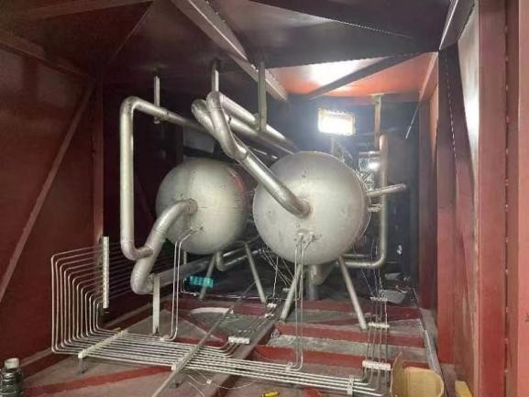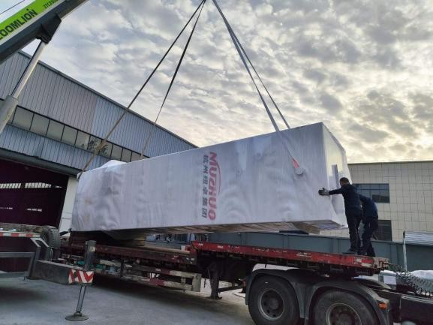

# Air bearing turbine expansion unit

1. The expander adopts gas bearing turboexpander, the impeller design adopts computer simulation design, and adopts five-axis coordinate CNC milling machine to process, and the efficiency is more than 82%.
2. In order to protect the safe operation of the expander, an alarm interlock function is set in the

value, the automatic control system will automatically alarm and stop.

|  |  |
| --- | --- |
| Manufacturer | Hangyang; Xida |
| Type | Gas bearing, fan brake |
| Model | PLPK-50/0.36-0.025 |
| Swell capacity | 310Nm³/h |
| Swell medium | Oxygen-enriched air |
| Inlet/Outlet pressure | 0.36/0.025MPa(G) |
| Inlet temperature | 130K |
| Brake medium | Air |
| Quantity | 2 Sets (1 for spare) |
| *Scope of supply of single set： |  |
| 1.Expander | 1×2 Sets |
| 2.Brake fan (assembled with main engine) | 1×2 Sets |
| 3.Air filter | 1×2 Sets |
| 4.Air silencer | 1×2 Sets |
| 5.Spare parts | 1 Set |

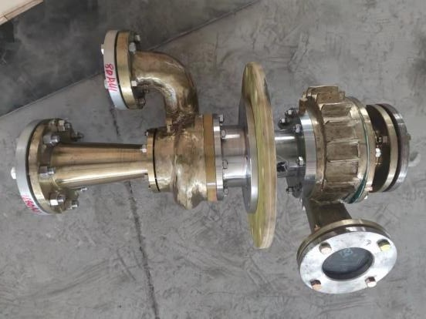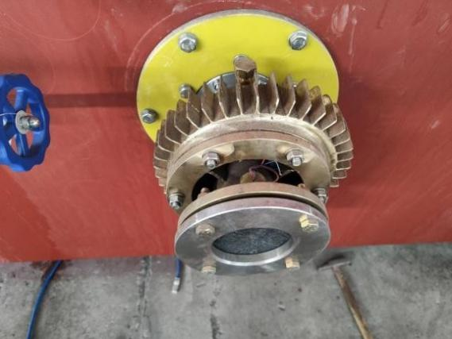

|  |  |
| --- | --- |
| Cryogenic liquid pump | 1 sets |
| Manufacturer | Sanjin |
| Model | SBP50-150/150 |
| Type | Horizontal, piston, electromagnetic speed regulation |
| Column number | Single |
| Design temperature | -196℃ |
| Working medium | LO2,LN2,LAR |
| Max outlet pressure | 0.8 Mpa |
| Max inlet pressure | 0.02Mpa |
| Max working pressure | 15Mpa |
| Design pressure | 16Mpa |
| Flow | 100-250L/h (Liquid) Adjustable |
| Motor work rate | 4.0KW |
| Weight | 450KG |
| Supply scope | |
| Cold end (pump head) | 1 set |
| Transmission case | 1 set |
| Pulley mechanism | 1 set |
| Foundation | 1 set |
| Cold end frid | 1 set |
| YCT | 1 set |

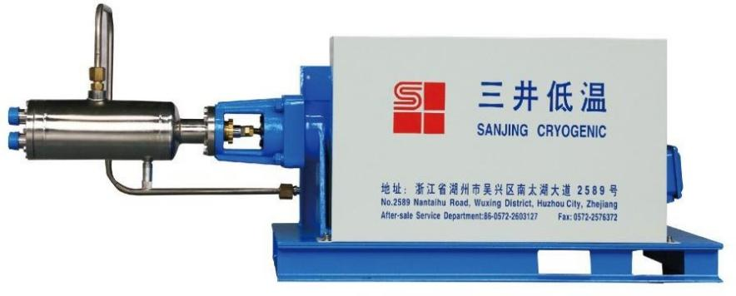

**13. Inflatable row**

|  |  |
| --- | --- |
| Manufacturer | Nuzhuo |
| Type | 6 filling heads*2 rows |
| Outlet Pressure | 15 MPa |

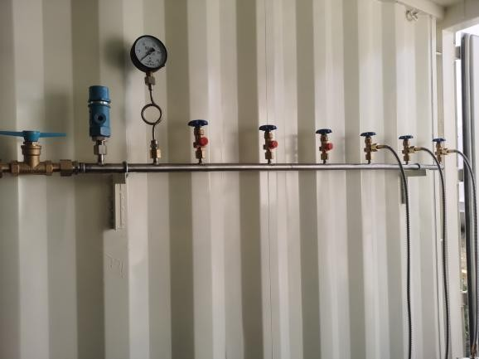

# Supply of electronic control system

* 1. Design principles:
     1. Under the condition that the electronic control system meets the design and process requirements, it must ensure that the equipment can operate safely and reliably, and is easy to operate and maintain.
     2. The setting of control, protection, metering and signaling devices for electrical equipment such as motors shall comply with the relevant national electrical standards or regulations.
     3. In order to improve the reliability of power supply,
     4. The electrical equipment is set up with a control panel next to the machine, on which the necessary electrical meters and signals and operating elements are set.
     5. When the low-voltage motor is started, the voltage drop of the low-voltage bus is less than 15%.
  2. Buyer provides power
     1. High voltage power supply: 10KV, frequency 50Hz, three-phase three-wire neutral point is not grounded.

Low-voltage power supply 380V/220 ± 5% three-phase four-wire neutral point is directly grounded.

* + 1. DC control power supply: DC220V.
    2. The buyer shall provide the power grid system diagram, short-circuit capacity and single-phase grounding capacitor current value related to the device within one month after the contract takes effect.
  1. Selection of electrical equipment (specific specifications and quantities are subject to the final design data)

14.3.1 High Voltage Switchgear

Type Mid-mounted vacuum switchgear

(Comprehensive insurance adopts Zhuhai Malata)

Technical parameters 10KV Incoming line cabinet 1 set 1 PT cabinet

1 measuring cabinet Compressor switch cabinet 1 set

Water resistance soft start cabinet (modified to solid state soft start cabinet) 1 set (Dayu Electric or Beijing Dali)

1 running cabinet

14.3.2. DC screen

Technical parameters DC220V Quantity 1 set (6KVA)

* + 1. Low-voltage switch cabinet (one main switch, two drawer cabinets) Type Drawer switch cabinet (Schneider components in the cabinet) Technical parameters 380V

Quantity 1 set

* + 1. Control cabinet (box) beside the machine

1 pre-cooling machine (pre-cooling machine factory matching)

* + 1. 1 set of heating furnace power adjustment cabinet

# Supply of Instrument control system

* 1. Design Principles

1. The instrument control system should be able to effectively monitor the production process of the entire set of air separation equipment, to ensure long-term stable and reliable operation of the equipment, and easy operation and maintenance.
2. Instruments and DCS series systems must be advanced and reliable, and reliability is the main consideration while considering advanced nature.
3. The instrument control system adopts the principle of combining the central control room (PLC), the instrument on the side panel and the local instrument control. All the interlocking (starting interlocking and protection interlocking) and control of the air separation plant are completed in the PLC , to ensure that the entire instrument control system is reliable, advanced, and easy to operate and maintain.
4. The controller of DCS adopts redundant or fault-tolerant controller, power supply and redundancy of communication bus to ensure the reliability of the system. The controller has the function of online modification.
5. In the air separation control room, set the upper computer monitoring and 1 printer to monitor the process parameters of the air separation unit, with functions such as display, operation, memory, report printing and maintenance.
6. Set up a printer in the air separation control room to print reports on the main parameters of the production process and print out the process parameters in the production process, various operation actions of the operator and system failures.
7. When the air separation plant is in normal operation, the display and operation are completed

on the PLC. Each main stand-alone machine is set up with instrument cabinets next to the

machine, and the functions of the machine side panel are as simple as possible. The need for start-up of stand-alone equipment.

1. All interlocking circuits are designed according to the ISA standard and using the principle of power-loss safety to ensure safe shutdown in the state of power-loss.
2. Set up an online analysis room, the analyzer is installed in the analyzer cabinet (including the pretreatment device) supplied in a complete set, and the process parameters of the online analysis enter the PLC system for display, recording, alarm and other processing, and the analyzers are equipped with 4- 20mA output signal, among which the analyzers involved in the interlocking have "measurement" and "calibration" switches, and the solenoid valve with dry contacts is sent to the central control PLC to avoid artificial interlocking and parking when the instrument is calibrated. Set up manual analysis of valve discs. The analytical sampling valve stand and each online analyzer are centrally installed in the analysis room.
   1. Instrument selection
3. The PLC system uses Siemens.
4. UPS uninterruptible power supply selects Santak products or Meilan Geran products (6KVA, 30MINS backup battery).
5. The pressure, differential pressure and flow transmitters use Yokogawa intelligent products.
6. The switching valve of the molecular sieve purification system is selected from American VALL or American Bray and the same manufacturers, and the normal temperature control valve and low temperature control valve are selected from Hangyang tooling or Wuxi tooling products.
7. The two-position three-way and two-position five-way solenoid valves are imported products with low power consumption from ASCO, and the brand of the regulating valve positioner is Azbil from Japan.
8. The online analyzer is supplied in complete sets and adopts international first-line brands Analytical instrument (1 set)

|  |  |  |  |  |
| --- | --- | --- | --- | --- |
| No | Item Name | Spec. | Qty | Remark |
| 1 | Oxygen Analyser | 0～10ppm | 1 Set | Siemens or equivalent |

1. The local instrument indication, the pressure indication on the instrument beside the machine adopts the spring tube pressure gauge.
2. The measuring element adopts platinum thermal resistance with PT100 graduation number, among which the resistance in the cold box adopts double platinum resistance, and the platinum resistance adopts the products of Anhui Tiankang or Shangzi No. 3 Factory.
3. Bimetal thermometer is used for local temperature indication.
4. The gas flow measurement adopts Hangzhou complete set of throttle orifice flowmeter.
   1. Scope of supply of meter (single set)

|  |  |
| --- | --- |
| 15.3.1 Main instruments |  |
| Pressure transmitter | ～25 Sets |
| Regulating valve and switching valve | ～20 Sets |
| Magnetic valve | ～15 Sets |
| Platinum thermistor | ~13 Pcs |
| Trace oxygen analyzer | 1 Set |
| Dew point analyzer | 1 Set |

|  |  |
| --- | --- |
| UPS | 1 Set |
| Pore plate | 3 Sets |
| 15.3.2 Instrument panel |  |
| Side cabinet of precooling machine | 1 Set |
| Analyzer cabinet | 1 Set |
| Molecular sieve purifier control cabinet | 1 Set |

* 1. DCS system (1 set)

|  |  |
| --- | --- |
| Upper computer | 2 Sets（DELL） |
| Configuration: |  |
| Operating floor | 1 Set |
| PLC Cabinet | 1 Set |
| CPU Unit | 1 Pc |
| Power module：24V/10A | 1 Pc |
| Printer | 1 Set |
| I/O points set aside 15% margin (less than one card for one card) | |

* 1. Other instruments

Including bimetal thermometer, pressure gauge, three valve group, DC current, etc.

* 1. Information and technical documents Meter list

Front layout drawing of side cabinet Electrical schematic diagram, gas circuit diagram, wiring diagram inside the cabinet

Instrument control system manual logic diagram

I/O point table

Alarm value, interlock list

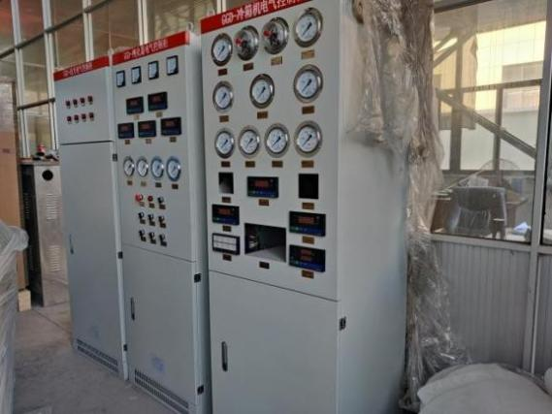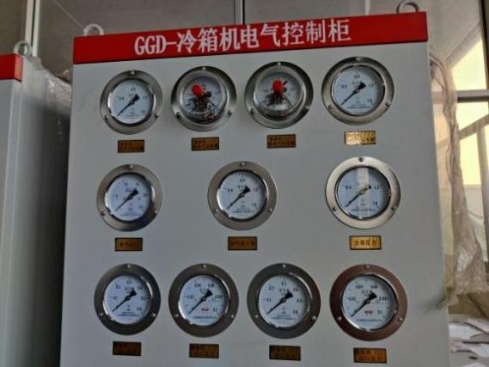

**16. Scope of work**

* 1. Seller's scope of work

1. The seller is responsible for all equipment design, process design, instrument and electrical control design, engineering design, equipment and accessories supply in the boundary area.
2. The intersection point of the pipeline between the seller and the designer is one meter outside the boundary area.
3. High and low voltage power distribution room and air separation control room are within the scope of engineering design.
4. The seller is responsible for the installation of pressure vessels and pipelines within the boundary.
5. The seller is responsible for the equipment of the local technical supervision department, the supervision and inspection fee of pressure pipeline, and the cost of flaw detection of pressure pipeline.
   1. Buyer's Scope of Work
6. The user should ensure that the quality of the raw air should comply with the provisions of Chapter 1
7. Design, equipment, materials and construction of public works and civil works, including equipment foundation, workshops and other buildings, lighting, sanitary facilities, water supply and drainage, communication, air conditioning, fire protection, heating and lifting facilities and various types of pre-buried pieces, etc.
8. Materials and construction of lightning protection facilities and grounding devices in the nitrogen production boundary.
9. Connect the high and low voltage power supply to the upper connector of the seller's incoming cabinet.
10. The instrument gas, nitrogen, water and electricity during the mechanical test, linkage debugging and start-up of the device.
11. Geological survey report, safety assessment and environmental impact assessment of civil engineering design.
12. The anchor bolts that need to be embedded in the civil engineering drawings shall be supplied by the buyer.

# Technical data provided by the seller

The seller will submit the technical data to the buyer according to the following scope and time. The technical data submitted by the seller will be provided in three stages: preliminary, final and random.

* 1. Preliminary technical data

The seller shall provide the equipment layout drawing and detailed survey layout drawing within two weeks after the contract takes effect.

The seller shall provide the preliminary design information required for the project in quadruplicate and electronic version within 30 days after the contract takes effect,

content include:

17.1.1 Complete Process Flow Diagram with Control Points

* + 1. The general drawing of the equipment (including auxiliary machines), the basic drawing, the middlemost drawing with the orientation dimension of the nozzle and the connection form Weight and special fittings (eg bellows, pipe filters)
    2. Reference drawing of equipment layout
    3. List of equipment (listed separately), including name, quantity, model, specification, manufacturer, etc.
    4. List of supporting instruments, including content: model, specification and quantity.
    5. List of supporting instruments, including content: model, specification and quantity.
    6. Auxiliary materials: Pearlescent sand, lubricating oil and water, electricity, steam consumption list (including specifications and consumption).
    7. PLC system configuration and external dimensions.
    8. Dimensional drawings of side plate and analyzer sampling plate
    9. Schematic diagram of main electrical equipment including terminal block wiring diagram
  1. Final technical information
     1. The seller shall provide the final design data of this device (equipment part) in quadruplicate within 60 days after the preliminary review. The specific information is as follows (but not limited to): The final version of the technical information, unless otherwise agreed on the same items below.
     2. Setting value of safety valve.
     3. The general drawing of all machines and equipment (including outline drawing, sectional drawing, structural drawing and foundation drawing) that meet the buyer's construction needs, and have the orientation and dimensions of the import and export.
     4. Meter List
     5. PLC system configuration diagram, I/O card assignment diagram and cabinet wiring diagram
     6. Front layout diagram, gas circuit diagram, internal connection diagram, wiring diagram and schematic diagram of machine side panel, analysis sampling panel, on-site control panel, etc. Schematic of a switchboard
     7. Electrical schematic diagram, terminal board wiring diagram, outline drawing of the cabinet (box) next to the machine, and list of electrical control equipment.
  2. Random data

The seller shall randomly provide the following documents in quadruplicate (one original and three copies) when the contract equipment is delivered.

* + 1. Cold box installation instructions and delivery list.
    2. Necessary factory standards and relevant guidance documents for installation, inspection, acceptance, storage, etc.
    3. Installation and maintenance instructions for each single piece (including instrument and electrical equipment).
    4. Operation manual of each stand-alone machine
    5. Process operation manual

In principle, the final drawings and documents provided above will not be revised. If revisions are indeed necessary to affect the buyer's engineering design and construction, the seller shall promptly notify the buyer in writing.

**18. Guaranteed value of the seller and the method of**

# inspection and acceptance

* 1. Basic conditions

The performance guarantee value of the contract equipment stipulated in this annex shall be subject to the conditions of linkage test after the installation and acceptance of the equipment, and continuous full-load performance assessment (including mechanical performance assessment) shall be carried out after being confirmed by the seller. in accordance with.

* 1. Performance Guaranteed Values

Under the design conditions, a single set of equipment can meet the following output: Main production A

|  |  |  |  |  |
| --- | --- | --- | --- | --- |
| Product | Output | Purity | Pressure MPa | Temperature ℃ |
| Oxygen | 50m³/h | ≥99.6% | 15 | Normal |

* 1. Measurement method and correction conversion Gas flow: measured by orifice flowmeter.

Gas purity: Measured by automatic analyzer and calibrated with standard gas. Gas pressure: use pressure transmitter or pressure gauge to measure.

Gas temperature: the indicated value of platinum thermal resistance or computer screen. Assessment conditions: The gas flow rate of the instrument is subject to the measured value of the gas flow orifice plate of the instrument, and the measurement value of the orifice plate of the outlet of the fractionation tower for nitrogen gas shall prevail.

Performance Guarantee: The device shall be checked and accepted within 7 days after the stable operation of the device meets the performance indicators for 48 consecutive hours.

Liquid measurement: use the gravimetric method or the liquid level measurement in the storage tank.

* 1. Acceptance procedures (implemented according to national standards)

1. The on-site representatives of both parties agree that after the project installation is completed, the buyer and the seller shall carry out stand-alone commissioning and trial operation according to the agreed procedure.
2. The detailed procedures required during the performance assessment period, such as the operational data to be recorded, the countermeasures and methods to be taken, the evaluation method of all the data of the mobile phone during the performance assessment test run, etc., shall be approved by the seller within 6 months after the contract takes effect. A detailed description is prepared and recommended to the buyer, a process agreed between the buyer and the seller prior to the completion date of the mechanical installation of the contract unit.
3. The performance assessment must be carried out after the device has achieved stable operation. The buyer should confirm whether the device is ready for the performance assessment test and notify the seller in writing.
4. To verify the performance assessment of all guaranteed indicators, the test time should last at least 24 hours for continuous normal operation and measurement. Measurements were made every 1 hour, and the average value was taken as the assessment result.

5) If the performance assessment is forced to be interrupted, the performance assessment

should be restarted. If it is forced to be interrupted due to the seller's reasons, the buyer should agree to extend the commissioning within one month, so that the seller can improve the device at its own expense and conduct another test. If the performance test is forced to be interrupted due to the buyer's reasons, the performance test shall be extended. When evaluating the actual operation performance of the contract device, the average value of all the measured data in the whole test period should be taken, and the allowable error of measurement and analysis and its certified value should be considered. The allowable error of measurement and allowable error of analysis should be agreed by both parties, and Guaranteed value refers to the performance assessment result, which is within the range of calculation error. (The error of the measuring instrument is implemented according to the national standard).

* 1. Quality Assurance and Service Commitment

Strictly in accordance with the ISO9001 quality assurance system for management, there are professionals who supervise the design, manufacture and service of products, and regularly control the sold products effectively to ensure the design quality of the products.

1. Strictly follow a series of procedures such as design input, design output, design review, design verification and design confirmation to effectively control the entire design process to ensure product design quality.
2. Develop a design work plan, specify implementation responsibilities, and hold a design work meeting to ensure that the design work is completed on time.
3. Strictly control the procurement of raw and auxiliary materials, outsourcing and outsourcing parts required for product manufacturing and services to ensure that the purchased materials meet the specified requirements.
4. In the whole process of production and service, the inspection and testing of products are controlled to ensure that uninspected or unverified products are not put into use, processed and shipped.
5. After the equipment is delivered to the site, the seller and the buyer will unpack together after receiving the buyer's written notice, and count them one by one according to the random packing list provided by the seller.
6. The seller promises to provide users with on-site guidance and debugging for the equipment provided.
7. After the whole set of equipment has been debugged and qualified products are produced, together with the relevant personnel of the buyer, the buyer will hand over the equipment to the buyer after the equipment has been stabilized for 72 hours, and at the same time, the buyer's operators will be trained on-site.
8. The seller provides various spare parts to the buyer in a timely manner, and provides life-long service for the complete set of equipment, and also undertakes service work for the current equipment to ensure that users have no worries.
9. The seller implements one-stop service for sales, technology and after-sales service, and the user service department tracks the sold products to keep abreast of the operation of the products and solve the difficulties of users.
10. After the equipment is running, whether it is a manufacturing quality problem or a problem caused by the seller's improper use, the seller will make a reasonable reply within one day after receiving the buyer's notice. until the buyer is satisfied.

**19. Random accessories list (single set)**

|  |  |  |  |  |
| --- | --- | --- | --- | --- |
| No. | Device Name | Specification | Qty | Remark |
| 1 | Oil mist filter |  |  |  |
|  |  | Filter element | 2 Sets |  |
|  |  | Electronic drain valve | 3 Pcs |  |
| 2 | Air precooling unit |  |  |  |
|  |  | Solenoid Trap | 2 Pcs |  |
|  |  | Fuse 2A | 3 Pcs |  |
| 3 | Molecular sieve  purification system |  |  |  |
|  |  | Switching Butterfly Valve O-Rings | 1 Set |  |
|  |  | Electric heating tube | 1 Set |  |
| 4 | Turbine expansion unit |  |  |  |
|  |  | Gasket | 1 Set |  |
|  |  | O-ring | 1 Set |  |
| 5 | Column |  |  |  |
|  |  | Analytical valve | 1 Set |  |
|  |  | Platinum thermal resistance | 1 Set |  |
| 6 | Air Compressor | Screw | 1 Sets |  |
| 7 | Cryogenic Liquid Pump | Sanjin | 1 Sets |  |
| 8 | Inflatable row | 10 Filling Heads | 1 Rows | 1*10 |

# Equipment and material delivery schedule and overall construction schedule

|  |  |  |
| --- | --- | --- |
| NO. | Project Period | Take effect by Contract |
| 1 | Validate contract |  |
| 2 | Develop a preliminary project execution plan | 0－7 Days |
| 3 | Design basic exchange meeting between supply and  demand sides | Within 7 days |
| 4 | Supplier internal contract review and determine  project execution plan | 8th day |
| 5 | Preliminary process design | 8－12 day |
| 6 | Process confirmation meeting | Within 15 days |
| 7 | Parameters of purchased parts are provided | 8－20 days |
| 8 | The parameters of electronic instrument control  purchased parts are provided | Within 30 days |
| 9 | Self-made product design parameters are provided | 8－20 days |
| 10 | Purchase parts and deliver preliminary technical data | 15－30 days |
| 11 | Electronic control equipment purchased parts | Within 40 days |
| 12 | Basic design of equipment and preliminary design of  instrument electric control | Within 30 days |
| 13 | Basic design Review Committee | Within 35 days |
| 14 | Detailed equipment design | 15－40 days |
| 15 | Instrument and electric control design | 20－40 days |
| 16 | Engineering process | 40－70 days |
| 17 | Self-made production | 40－115 days |
| 18 | Equipment inspection and acceptance | 115－120 days |
| 19 | Equipment delivery | 150 days |
| 20 | Equipment installation | 120－160 days |
| 21 | Trial run (mechanical trial run) | 175－185 days |
| 22 | Cold box raw cold feeding test and assessment | 185－195 days |
|  | | |